CMOS INVERTOR ANALYSYS

Given parameter: library :90gpd

L:100nm

W:120n

Vdd:1v

Pmos 1, Nmos1

1)Cmos schemetic :

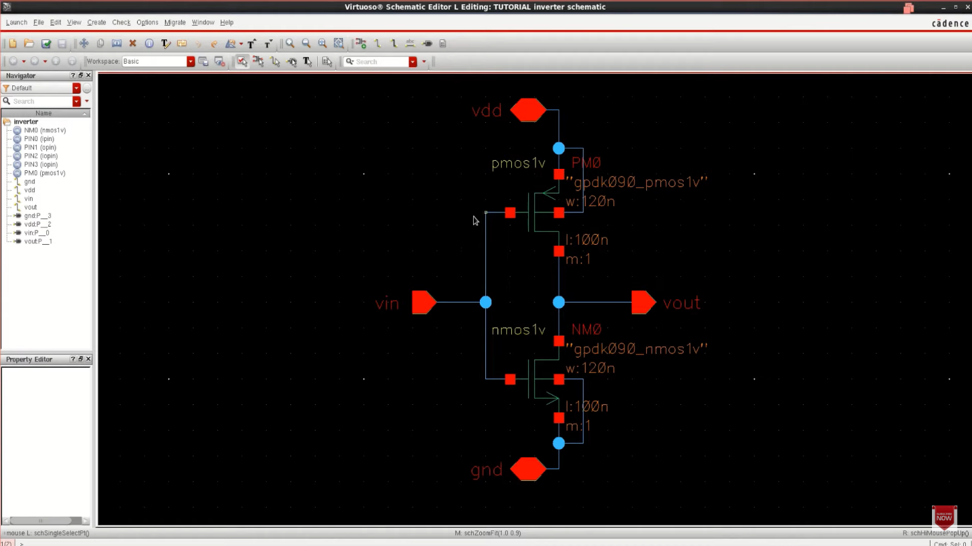

2) symbol for invertor

3 ) input output voltage waveform, device current and VTC

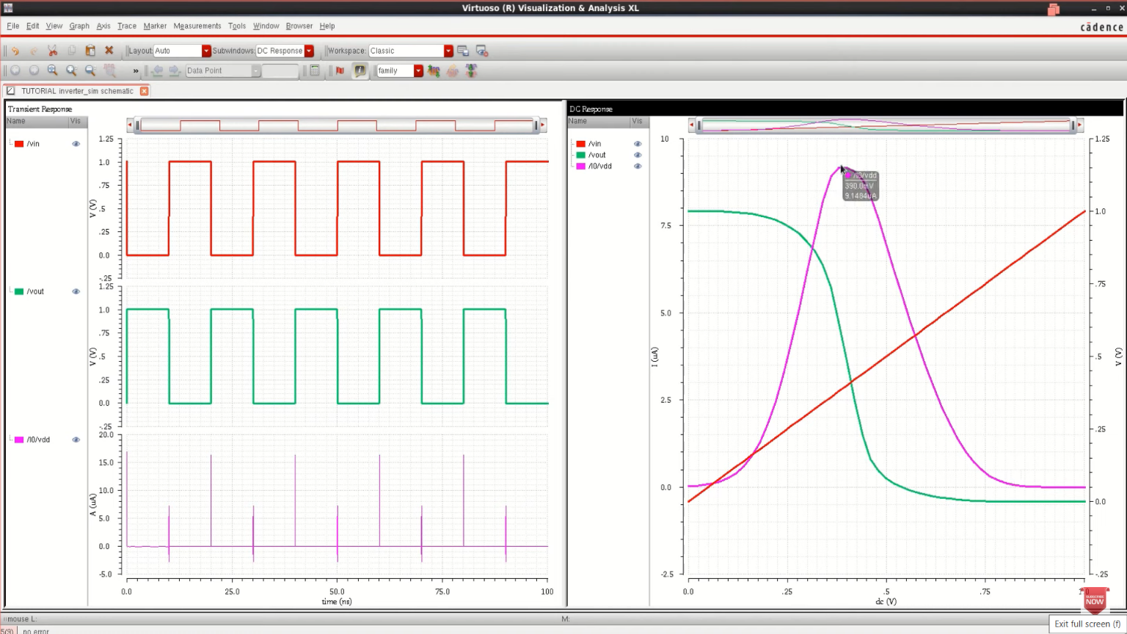

4) Stick diagram / layout: 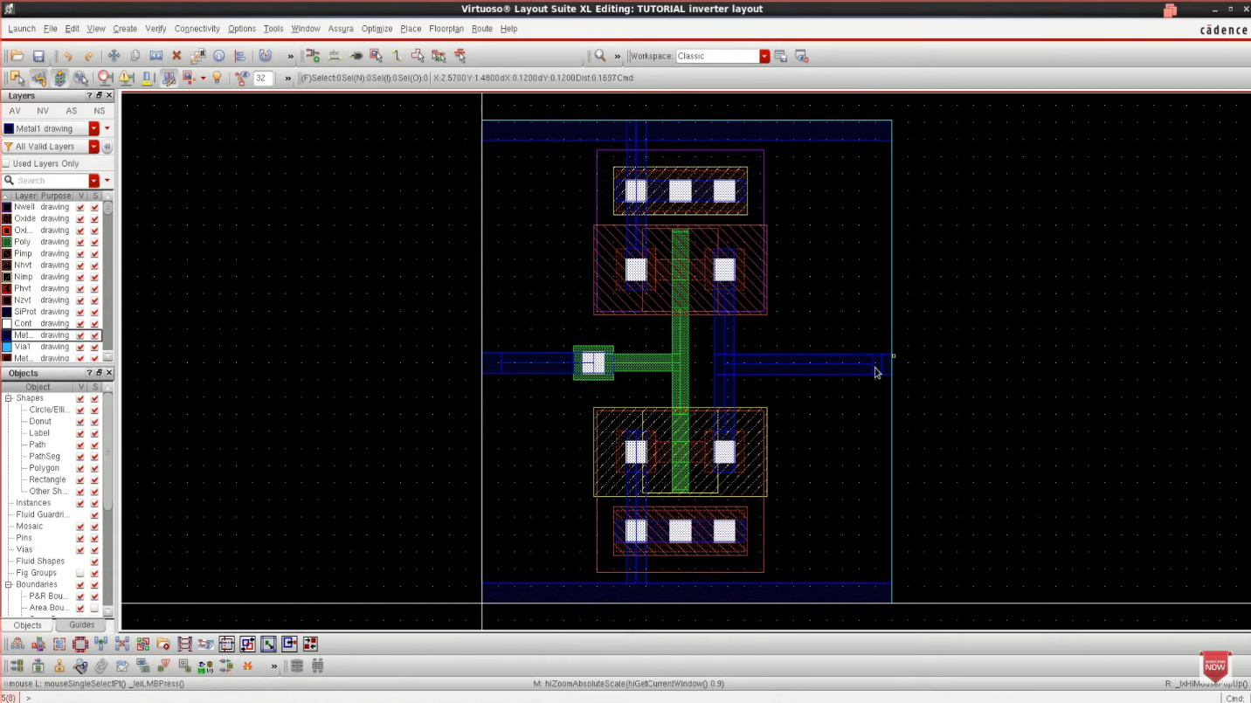

6)transient response and delay

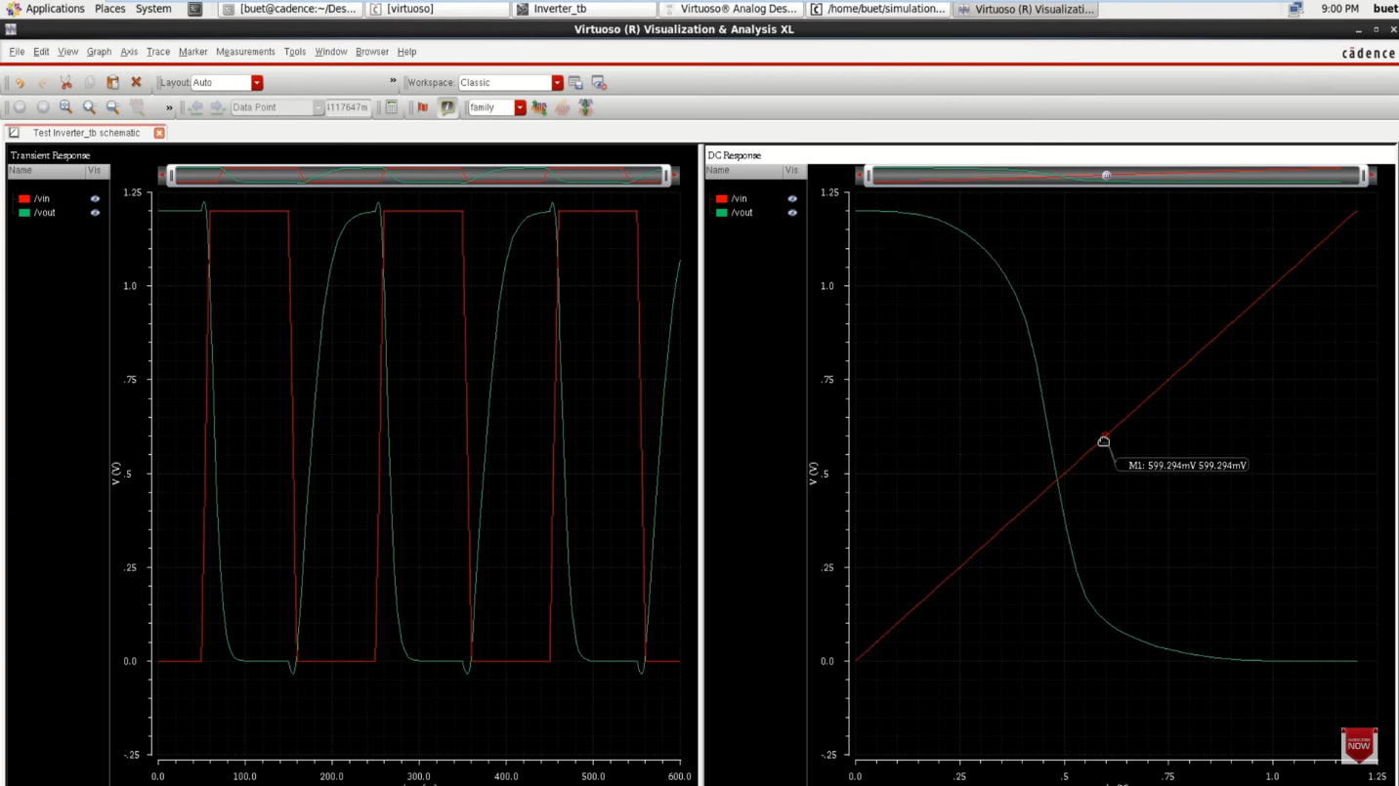

7)parametric analysis :120n<Wp<500n

